BBUS 3331- Introduction to production and operations management
Assignment 1: Nature of Operations, Strategy, and Productivity
A short aide de memoire
Thompson Rivers and I want you to succeed.
I thought it might be helpful to supplement the materials for Assignment #1.
Boilerplate.
- I believe scanning the following materials may enhance your assignment grade.
- Word /Excel --- No PDFs or photographs please... Cannot enter feedback on the document.
- Please put your name on your assignments!
- The assignments generally provide a suggested number of words to obtain a good mark. You can of course provide less but that comes at a cost of less research and that makes “the challenge” for full marks more difficult. If you find you’ve gone over the suggest word count - not a problem for me—if you have something important to say--- say it!
- Marks are based on the quality of the submission, not the quantity of the words.
Task-
# 1 - 10 critical decision areas in operation
You are asked to choose a “firm” . Select one with easy to find data. Provide 5-8 sentences on each of the topics… (Total approximately 800 words).
Your report must be readable, well-organized and grammatically correct. The data you presented must be relevant to the operational areas you introduced…. (recall 10 areas.)

#2 Analytics Exercise: Comparing Companies

You were asked to analyze two industry-leading firms and Using the wall street efficiency measures evaluating the pros and cons of each firm in relationship to the other.
You were expected to follow the four steps.
In step 1 and 2 --- financial ratios--- Suggest you present your findings in a matrix with the appropriate data displayed.
Not to limit your financial analysis, make sure you include in your calculations the income per employee, revenue per employee, receivable turn-over, and inventory.
I have provided a aide de memoire on financial ratios for small business n this file… I think you’ll enjoy it...
Financial Corporation(s) Efficiency Competitive Analysis- A short aide de memoire ( All you need to know about financial ratios in an accounting course).
Step 3 requires you to provide detailed answers. I am looking for comparisons regarding production of employees, best processes, efficiency using credit, efficiency of using assets and any other ratio you found interesting.
Step 4 requires you to provide your findings based on your analysis... Looking for overall insight and benchmark suggestions. This is a key part of the exercise—Evaluating the data, drawing conclusions and critical thinking… “Show me the money!”

#3 Tha Tao of Timbuk2
Using the case study --- “Tha Tao of Timbuk2” you were asked to answer 3 questions (expected about 600 words).
Asked to identify the key competitive dimensions and made observations regarding the competing priorities for the new laptop source from China.
You considered the two categories of products and ID for the custom messenger bag the key competitive dimensions that are driving sales.
Remember to include in your discussions the different competitive priorities for the new laptop bags sourced from China.
I I will be looking for your ability to identify the key competitive dimensions, the comparison of the assembly line between China and San Francisco on four dimensions,
I want “a drawing” of the two supply chains, and you to ID any additional costs-

4. Service Recently Received
In this question you’re asked to reflect upon a service you recently received.
You are provided specific questions to respond to in about 500 words.
ID important service design attributes that had to be considered and discussed the reasoning behind each selection.
Provide the service system design matrix ( a figure + explanation).. . Something like these… …
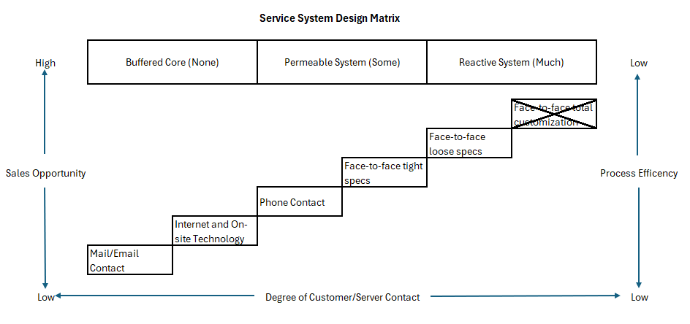
I want to see strategies for customer introduced variability.

#5 South Beach Pizza
You were asked to examine the service process design for the subject pizza facility.
The analysis required about 600 words.
As a guide you were provided with 4 questions.
You are to provide the following:
- The pizza delivery attributes that were important to their customers;
- A list of pizza delivery design requirements (to include how you would ensure the process met the requirements)
- Comment on how the design process meets your requirements using a flowchart to assist in your explanation.
===

It is important in your references when you use Urls that you provide the date you access them.

Again, Thompson Rivers and I want to see you succeed!
Hope you find this aide de memoire helpful... I have provided a number of similar but shorter aide de memoir(s) for the remaining assignments.
You may find them worth reading only if you have the time and interest.
Again, these materials are not part of the course but only supplements that I provide as courtesy.

