Research links- Aide de memoire

Often students unfamiliar with the law are unsure where to start their research.
I thought it might be helpful tp provide some “start points” to get you underway.
I don't look for a lot of cases -- one or two... -- it has taken me a little while to collect these materials for my ref– I will share with you--- it certainly can be overwhelming trying to find the rules (law)... Law that speaks to the issues you identify in your assignments.

You have of course on the class site a link to the BC Statutes. Search by the name (concept or notion) their you believe it should be under ---such as trespass, negligence, motor vehicle, joint tenancy, etc..

You will find in your textbook the concepts and notions surrounding the issue(s) you have identified a case(s) and citations.

I found this matrix helpful …

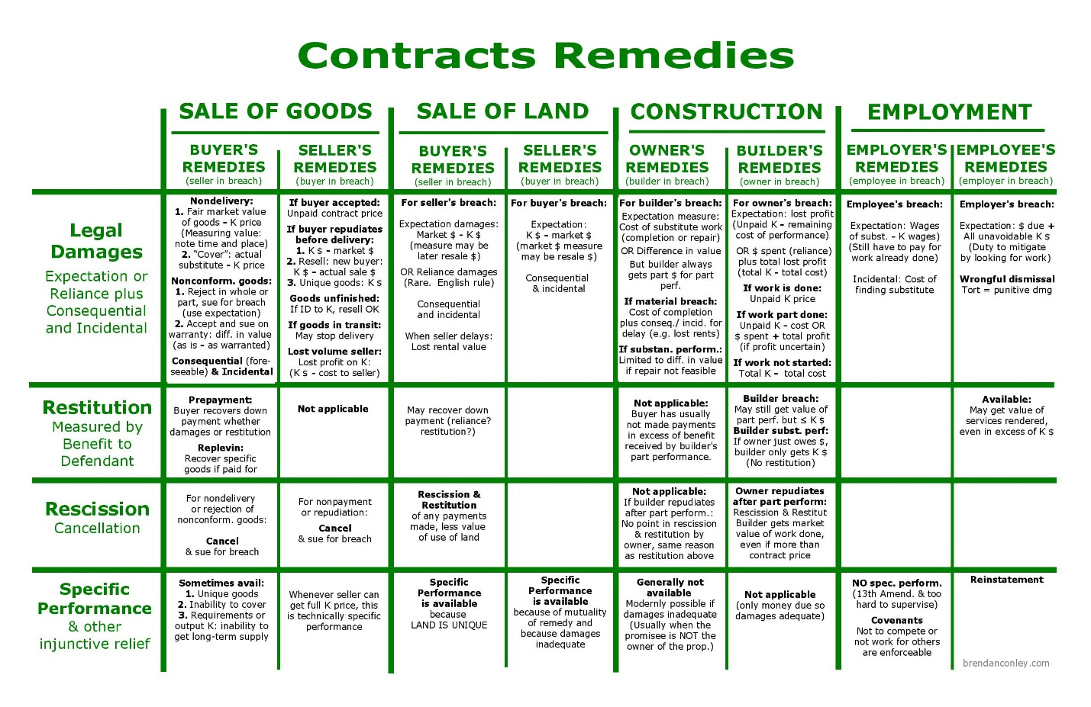

You can also search for law on the Internet… For example... “The law Canadian law makes criminal harassment an offence punishable by summary conviction or by indictment. This offence currently carries a maximum penalty of ten years in prison. Section 264. (1) of the Criminal Code specifies: 264. (1) Criminal harassment - No person shall, without lawful authority and knowing …. “
Criminal Harassment

www.crcvc.ca/docs/crimharass.pdf

SOME More STUFF

https://www.bclaws.ca/
Frequently Viewed Legislation
- Public Statutes and Regulations
- Private, Special and Local Statutes and Regulations ntly Viewed Legislation
- Child Care Licensing Regulation – 332/2007
- Child, Family and Community Service Act
- Employment Standards Act
- Family Law Act
- Freedom of Information and Protection of Privacy Act
- Labour Relations Code
- Motor Vehicle Act
- Personal Information Protection Act
- Real Estate Services Act
- Residential Tenancy Act
- Strata Property Act
- Supreme Court Civil Rules - 168/2009
- Wills Estates and Succession Actnd Updated Legislation
- Cannabis Control and Licensing Act
- COVID-19 Related Measures Act
- Emergency Program Act
- Income Tax Act
- Occupational Health and Safety Regulation - 296/97
School Act Jurisprudence
- 1028840 B.C. Ltd. v The Heritage Dispensary Clinic Society, 2018 BCSC 82, 2018 CanLII S1711014.
Google
Contract Law Cases – Examples

Carlill v Carbolic Smoke Ball Company established that an advertisement promising a reward can constitute a binding unilateral contract accepted by performance.

  - Coward v. Motor Insurers’ Bureau (1963) 1 QB 259 (CA) In this matter Mr. Coward and Mr. ...
“contributory negligence" law - Bing
“Contributory negligence, in law, behaviour that contributes to one’s own injury or loss and fails to meet the standard of prudence that one should observe for one’s own good. Contributory negligence of the plaintiff is frequently pleaded in defense to a charge of negligence. Historically the doctrine grew out of distrust of juries, which have usually been more sympathetic to plaintiffs in personal injury lawsuits.”
PEOPLE ALSO ASK
What is contributory negligence in tort cases?
Can contributory negligence be abolished?
What was the Contributory Negligence Act of 1945?
What is compensatory negligence reform?
In some common law jurisdictions, contributory negligence is a defense to a tort claim based on negligence. If it is available, the defense completely bars plaintiffs from any recovery if they contribute to their own injury through their own negligence.
Lots of videos on topic Tort Law: Contributory Negligence - Bing video

It is good practice in your answers that you provide’ further evidence’ than just the textbook.

Statutes and case law are better than textbooks to support your “opinion’s.

So, no easy way-- lawyers have to think critically and attempt to connect the dots; … that’s what you’re asked to do in the assignments; not as simple as going to “page 69 and writing down the five bullet points”..
Need to research.. Hope this helps … terry

Visit Blog https://terrypowerstrategy.com/

See notes on exam ---

