THE CASE STUDY PROCESS (USING THE TOOLS)

Similar to those who write Harlequin romance novels, case study writers generally follow a recipe.

Understanding this concept is worth the price of this handbook. It will save you considerable time.

The time has come to prepare your doodle-page. I would recommend that you use the fishbone doodle tool from your toolbox. Using just sufficient words identify the concept, issue, notion, etc. arising from the contents of the case. Record them under the generic headings found on the fishbone. Below is the fishbone doodle applied to the Cobbler Case.

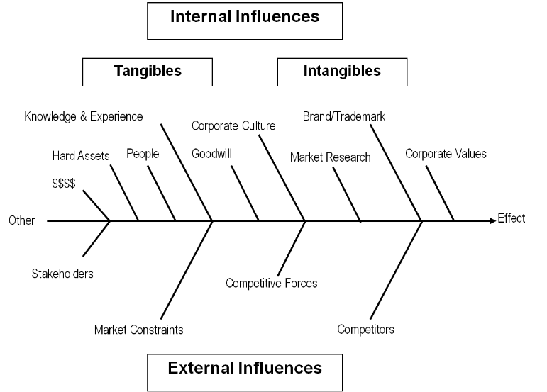

Step 1 - First Read. In less than 20 minutes you should be able to 'get into the game'. I am not advocating being slipshod in your study practices. Rather, because case studies follow a writing ‘recipe’, you will be able, within 20 minutes, to substantially answer Kipling’s questions and acquire a high-level overview of the issues emerging from the case study.

In well-written case studies, the writer sets out the essence of the case issue in the first and last paragraphs. The opening paragraph or so sets the stage. Read quickly through the opening half of the case then, about halfway through, slow down and start making notes so that you can begin your analysis.

Examine any appendices, exhibits, and any other attachments. If the instructor has provided questions, review them. You should be able to quickly identify the core issue(s) with which the decision- maker is wrestling. Case studies generally move from the general to the specific.

Remember to continue to record your thoughts on your case doodle-page. For example, what is the current vision and mission statement? What are some of the internal tangible and intangible factors (brand, personnel, money etc)? What are some of the external influences (market, competitors, competitive forces, etc.)? Record your thoughts on your document.

Step 2 - Second Read. Having completed the 20-minute scan and started highlighting and documenting your observations in an abbreviated form to your doodle page; undertake the second read. This time, you are looking for the detail to flesh out the high-level observations you have made during your initial 20-minute scan. To assist you in this more detailed process, you should follow this business decision making process in sequence to determine the preferred recommendation or options needed to respond to the issue(s) faced by the case decision-maker. Initially you will follow the model in sequence, but once you have completed the process it becomes an iterative process that is driven by the feedback, dialogue, and evaluations used to adjust the model. You will need your toolbox again.

What General Questions Need To Be Answered?
You are now ready to undertake your case study analysis. To guide you, refer to your case doodling page that provides the key words and phrases that you have deemed important for analysis. It is important that you maintain a rough record of your thoughts for ongoing reference and in-class discussions (your cheat sheet). Your doodle page will substantially meet this need if you keep in mind Rudyard Kipling's six honest serving men.

Maintain Kipling’s questioning approach as you undertake your case analysis. Full and complete answers to Kipling’s questions (what, why, when, how, where and who) will provide you with the issues, problems, choices, and most of the information that you'll consider in order to select the appropriate course of action for each case.

Specific Questions That Need To Be Answered

The Cobbler Case is a strategic management case study.

Thinking strategically involves three key questions: Where are the Frasers’ now? (What is the current state?) Where do they want to go? (Which business(es) should they be in, which market(s) should they target, what are the buyers’ needs, which groups should they serve, and what outcomes should be achieved)? How do they get there? (The recommendations and implementation plan.)

NOTE: Case avail in the Power Handbook!

Some of the specific questions that require analysis in this case would include: What is the Cobbler's current vision and mission? What are the company's resource strengths and weaknesses and external opportunities and threats? Is the present strategy working? What factors are driving changes in the shoe industry? What is the nature and strengths of the shoe industry’s competitive forces confronting the Cobbler? Does the industry present an attractive opportunity? What strategic issues or problems do you see for the Cobbler? What viable options does the Cobbler have? What recommendations would you make?

It is questions such as these that you will reflect upon and subsequently discuss with your classmates. Keep in mind that at the end of the day, the important thing is not which recommendations you select for the Cobbler's enterprise. Rather, the key is that you and your classmates have a full discussion of the concepts and notions emerging from these and the other questions you will address.

The case study serves only as the context for your discussions.

BUSINESS DECISION MAKING PROCESS: CASE ANALYSIS

You now have a good understanding of the case, and you have recorded the high-level essence of the case and categorized it into clusters on your case doodle-page. Now we need to analyze the data and provide our findings. You must show that you understand the situation and the critical elements in the external and internal environments. Unless you can demonstrate your mastery of the situation, anything you recommend can be easily dismissed by the recipient of the report. You can get away with not addressing analysis in a presentation because the audience can ask questions during or after the presentation. In a written report however, you only get one chance to make your point, so you must anticipate the questions that the reader might ask.

So, which analyses do you need to do? The answer is – all of them!

You must use all the tools at your disposal. What do you present, though? The answer to THIS question is – as much as you need to frame the strategic context. In all cases, you will undertake a SWOT analysis, and while the financials are usually minimal, you should undertake financial analyses, nevertheless. Both primary tools are important for identifying capabilities and warning flags within the company.

Of particular interest are the trends that you see in capability; the direction in which the financial, managerial, and personnel capabilities are headed.

Internal analysis is not enough though; it must be set into the strategic and competitive context.
Busy executives are generally better informed about internal realities than they are about external realities, so a robust, disinterested discussion of the external realities will usually be considered a real benefit by senior managers. Simply using a new tool to illustrate the competitive playing field can provide new insights that can reshape a manager’s thinking.

In the preceding sections, I have provided a brief overview of some of the tools available to you. Besides the two primary tools, which of the other tools might you consider? For your own benefit, you should always undertake a few additional analyses using the other tools.

The major conclusions you reach from these analyses might be useful to your audience of executives. For example, identifying the key competitive drivers is always beneficial, as is the list of key success factors for the industry. It is always interesting to compare a company’s capabilities and competencies with the industry’s KSFs, and you can often identify important gaps in this manner. As with the internal analysis, it is always useful to look at trends to see where they are leading.

All this analysis needs to be kept in strategic context, so the first thing you need to do is to identify the strategy that the company is currently executing. Often a statement of the “strategy in action” will uncomfortably surprise managers, particularly when it is backed by solid evidence.

The gap between the stated and executed strategies can sometimes be vast. Using a statement like this to anchor either a presentation or a report can be powerfully beneficial.

Drawing from the information in the Cobbler case, undertake the business decision making process using this model.

Business Decision Making Process: Case Analysis
Feedback & Evaluation

Copyright: T. Power 2007

Step 1 - Define the Issue, Challenge, or Problem The first step in the process requires you to identify the core issue, challenge, or problem - the question to be addressed. It is critical that you do not identify a symptom as the core issue because all the steps that follow relate to an analysis of this question. Just as a photographer focuses his camera, make sure you have taken time to get a clear picture of the question you have been asked to analyze. In the Cobbler case, while there are many questions, one key question might be whether the current vision and mission statement remains valid.
Step 2 - Establish the Metrics Criterion for Valuation Nothing demonstrates your understanding of the strategic and competitive realities better than the criteria you develop to help you judge among the strategy alternatives you identify. These criteria come directly from the analysis, and they provide the key constraints to strategic action. They can be qualitative (employee morale, brand, goodwill) or quantitative (financial performance ratios).

In the Cobbler case, if you identify a need to implement a change in direction quickly then time will be an important criterion. If developing new capabilities is critical to the Cobbler, you can bet that this will appear in the list of criteria. It is always more important to identify a criterion than it is to carefully construct the criterion statement. If you do not identify the criteria, the reader of your report is at a loss to understand how you determined that your recommendation is the most appropriate for a new or improved strategy. Therefore, when you fail to develop decision criteria, you also fail to build the reader's confidence in your analysis and consequently they will be reluctant to accept any of your recommendations.

The most appropriate place to list your decision criteria is in an appendix.

However, as in all cases, you need to provide a powerful reason to motivate your reader to turn to the appendix. Therefore, the critical conclusions from your criteria development need to be in the body of the report before you refer your readers to a specific appendix. Having the only reference to an appendix read something like, “I have thought about criteria - see Appendix A” does nothing to fire someone up to go and read it.

Step 3 - Identify All Reasonable Alternatives Develop alternatives for addressing the ‘gaps’ (issues) that exist in the Cobbler's current situation. There are ALWAYS two or more alternatives. If there were no alternatives, there would be no need to make a strategic decision. We would simply do the urgent and obvious things.

Step 4 - Analyze all reasonable alternatives There is no 'best' alterative; no 'right' answer.

We select the most appropriate alternative given the circumstances. Change the circumstances, primarily the criteria, and you will likely change your understanding of the most appropriate alternative. When discussing your recommended alternative, it is important to discuss the alternative in relationship to all of the criteria you have developed.

If you do not discuss a criterion, it cannot be important.

You can quickly dismiss the less appropriate alternatives in a sentence or two by reference to the criterion each fails to satisfy. Identify the internal and external influences. Peel the onion. Thoroughly sift through and analyze the case data to identify the root causes.

Often, I find the best way to do this is to establish a table in which to evaluate each alternative against each criterion. This table can be a very powerful summary of your forward-looking thinking. The SMART tool would work well here.

SEE The simple multi attribute weighting technique (SMART) tool at ( SEAN Insert link please here)

Step 5 - Select the Preferred Alternative. Having reviewed all the alternatives, you now provide the instructor in your opinion the preferred alternative supported by evidence. I generally find it a good practice to place the preferred alternative at the end of the discussion of all reasonable alternatives.

Step 6 - Implement the Action Plan For the preferred alternative, you should now provide a very high-level action plan outlining the essence of how you propose implementing the recommended alternative.

Step 7 - Feedback and Evaluation This final step is undertaken to incorporate consideration of feedback, class dialogue, and further evaluation of the material facts arising from the case. Two heads are better than one and so it would not be surprising to find that thoughts presented by your colleagues may influence the conclusions you reached prior to this process.

At this point, the Business Decision Making Case Study Analysis Process becomes iterative. It requires you to revisit the steps to accommodate the new information and data and to ascertain whether your hypotheses, alternatives, and recommendations continue to be valid.

With the addition of a Table of Contents and an Executive Summary, this Business Decision Making Case Study Analysis Process provides you with most of the major headings you will need to write your case study analysis report.

You will find a template for a case study analysis report in Chapter 6 of this handbook. In the next section of this handbook we will be examining some practical writing concepts, templates, and practices to include citations that you will need when preparing your case study analysis.

Final Thoughts - Writing the Case Study Report So now that we understand what case studies are, why we do them, and what tools we have available, it is time to write the case study report. Remember, we can all benefit from reading and rewriting what we present, and there is plenty of time available to you for reading and re-crafting your reports. You want to take advantage of this because you can always make your writing more powerful, and you can usually find concise ways to pack more information into your reports.

Please write to the person indicated in the case study as the recipient; this makes the writing easier. But please keep your writing professional; this person is not an intimate friend. Also, please keep slang out of your reports. Some slang can be quite effective in presentations (if you know your audience) but as a rule, should be eliminated from any writing that may be distributed to non-native speakers – and that includes all business writing. Further guidance on writing reports is found later in this handbook.

Your instructor will be looking for an assignment introduction as well as an appropriate recommendation that takes into account all of the data and information you have briefly recorded on your documentation doodle-page. While critical analysis is extremely important, it is also important that you demonstrate your communication skills, both written and oral.

