Fishbone - Cause and Effect Model

A Fishbone doodle helps you to set down possible causes/major issues and the effects experienced by the organization/person as the central entity in the case study. In constructing the doodle, make sure you drill down to identify the basic reasons or root causes giving rise to the problem presented. It can be an objective (effect) or a problem (effect). It is important that you not stop the analysis at the symptom level. Drill down. Using this doodle or one of the others will help you to think in a systematic and rational way. It will ensure that you do not overlook important aspects of the case.

To prepare a fishbone doodle undertake the following steps.

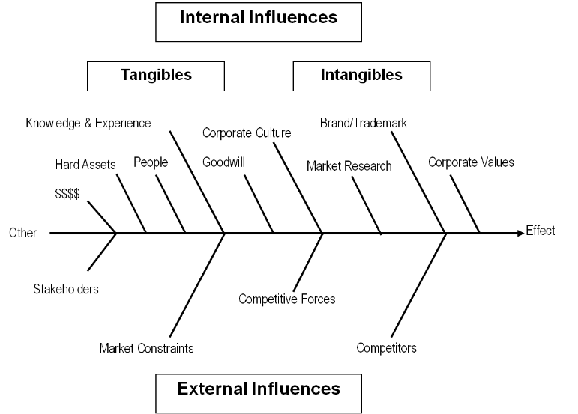

Step 1: Draw a fishbone identifying the major challenge. In a succinct sentence; set out the problem in a box on the doodle page. Undertake a fishbone doodle for each major ‘core’ problem.
Step 2: Identify the main causes that give rise to the problem (effect) being analysed. Causes are generally people, machinery, plant, materials, procedures, policies, environment, methods, and the list goes on. The example below provides graphically the generic causes most likely found in a management case study.
Step 3: For each cause, identify other factors and attach them as ‘sub bones’ until you have exhausted the exercise.
Step 4: For each ‘sub bone’ now add additional ‘sub-sub bones.
Step 5: Push back from the table and analyze the data on your fishbone doodle. Are there further causes or causes requiring more discussion? Clusters of 'sub-bones' and 'sub-sub-bones' may indicate that further analysis is needed.

