International Business Assignment 4- International Finance and Monetary System
A short aide de memoire

Thompson Rivers and I want you to succeed.
I thought it might be helpful to supplement the materials for Assignment #1. Specifically, regarding xxx and other related matters.
Boilerplate.
- I believe scanning the following materials may enhance your assignment grade.
- No PDFs or photographs please... Cannot enter feedback on the document.
- Please put your name on your assignments!
- The assignments provide a suggested number of words to obtain a good mark. You can of course provide less but that comes at a cost of less research and that makes “the challenge” for full marks more difficult. If you find you’ve gone over the suggest word count - not a problem for me—if you have something important to say--- say it!
- Marks are based on the quality of the submission, not the quantity of the words.
In this Assignment, you, continued to examine international business issues related to economic co-operation, regional economic integration (trading blocs), and the international monetary system.
You commenced the Assignment by examining and identifying the best Trading Bloc that is ‘the best fit’ for your venture.
I expect you to provide your thoughts on a number of relevant trading blocks. Advantages and disadvantages. ‘Like a marriage’, you’re looking for an alignment of values, culture, emerging threats, risk analysis on several fronts etc.
A good example is Canada selecting the appropriate submarine ‘package’ from either South Korea or Germany. As Canada economically decouples from America’s our Prime Minister Mark Carney is faced this very question… Which option offers the best value for money for Canada in the long term. There’s much to think about! The decision should be announced by the end of June 2026. If you have the time and interest watch for the rationale that grounded his decision.
In this assignment you will also demonstrate you are familiar with the concepts of notions surrounding money markets and financial exchanges. To include the role they play in imports, exports, the balance of payments, and the strengthening or weakening of the nation’s currency.
Support your answers with appendixs and figures such as this..
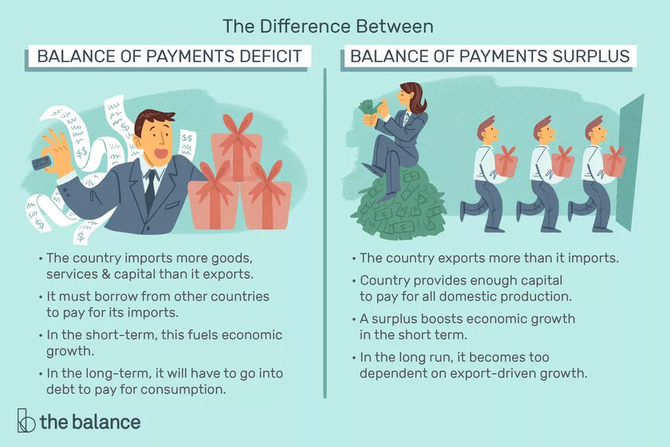
(Amadeo & Boyle, 2021)
Materials you collect doing this assignment for a major project I’ll be looking for your thoughts regarding:
- Economic stability
- Currency fluctuations and inflation
- Rising nationalism and other political uncertainties
- Potential changes in administrative trade barriers
- Accounting practices
- Taxation
- Relevant cultural or technological forces
In this assignment I want you to demonstrate critical thinking and reflective thought. I you to identify the risks your venture is likely to encounter.
Again, Thompson Rivers and I want to see you succeed!
Hope you find this aide de memoire helpful... I have provided similar but shorter aide de memoir(s) for the remaining assignments.
You may find them worth reading only if you have the time and interest.
Again, these materials are not part of the course but only supplements that I provide as courtesy.

