How about an Acid Rain “set off” against Trump’s proposed tariff on Canadian smoke?
Extremely dry weather served as a catalyst for over16 million hectors with 6000 record breaking major forest wildfires in Canada. The most ever recorded in history. It is Canada’s Black Summer.
A record-breaking large number of Canadian families --- homes lost, livelihoods lost, acres of forest ruined. See Bing Videos
International deployment --- Australia and South Africa --- fire fighters assisted in Alberta! EU nations were busy with their own major wildfires!
Carney responded : “ … noting more than 5,300 firefighters had been deployed nationwide while authorities relied on advanced data systems and thermal imaging technology to detect and contain new fires as quickly as possible. See Trump warns Canada that punishment is coming: 'You'll find out soon'
President Trump Response --- put a big tariff on Canada because of the smoke. He suggested it was a self-inflicted wound by Cannada. Yes, Ontario budget constraints reduced its firefighting budget. But President Trump might reflect on Canada as the second largest landmass in the world with only 40 million people it is difficult to keep the forest “clean”.
“Trump described the smoke crossing into the United States as an invasion and imposed a 50 percent tariff on a range of Canadian imports, citing what he called Canada’s discriminatory treatment of American products”. He further stated ... “Punishment is coming”. When pressed he said: you’ll find out”. (see Trump warns Canada that punishment is coming: 'You'll find out soon')
A suggestion our Prime Minister might consider . A “set-off” against President Trump’s smoke claim --- Acid Rain Damage.
Through the 80s and 90s sulfur dioxide and nitrogen oxide resulting from fossil fuel combustion destroyed much of central and eastern Canada ecosystem.
The USA’s acid rain with its PH level below 5.6 seriously impacted Canada’s ecosystems. In Eastern Canada over 150 lakes were severely affected.
Prevailing wind patterns then and to a lesser extent today continue to carry a substantial volume of these pollutants from heavily industrialized regions of the United States, particularly the Ohio Valley, into Eastern Canada.
As a result of agreement in 1991 between the United States and Canada both parties agreed to mitigate the damage of these sulfur emissions. Today the impacted lakes have shown significant improvement, with some beginning to support aquatic life.
But the recovery still is not complete—the damage continues. Some lakes, particularly in Nova Scotia remain damaged from decades of acid deposition with many more decades before these pristine lakes returned to their pre acid rain state. Nova Scotia and New Brunswick are known globally for their salmon rivers like the Miramichi and the Cains in New Brunswick.
“The acidification of freshwater systems was one of the most visible impacts, with thousands of lakes across Ontario and Quebec experiencing sharp declines in pH levels. Studies in Quebec revealed that 19% of lakes had a pH below 5.5, a level at which many fish species cannot reproduce. This led to the decline and, in some cases, complete elimination of fish populations, particularly in Nova Scotia’s salmon rivers.
Canadian Shield & East Coast provinces (Ontario, Quebec, Nova Scotia, New Brunswick) are hardest hit • their water and soil systems can't neutralize the effects of the acid rain • > 150 lakes are “dead” and 48 000 are at risk of acid rain destruction • > 90% of the acid deposition in eastern Canada originates from emissions in the US Midwest.”
SOURCE: See us acid rain contaminates Canada's Eastern provinces lakes - Search Images
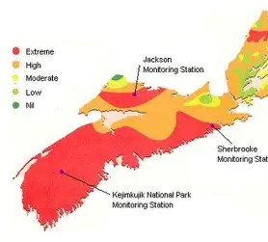
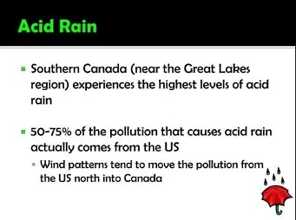
acid rain contaminates Canada's Eastern provinces lakes - Search Images
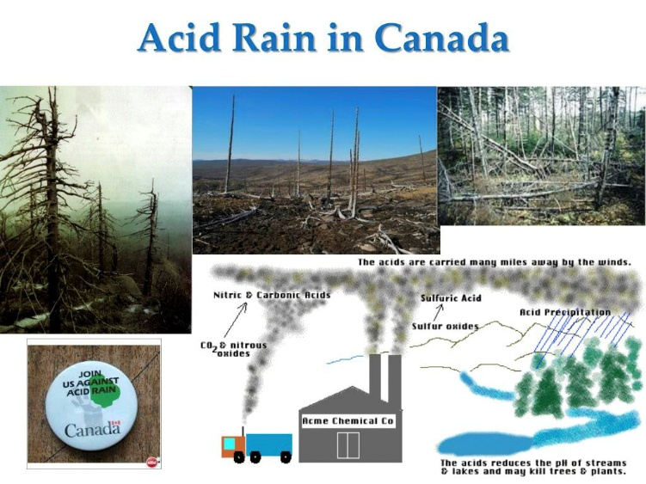
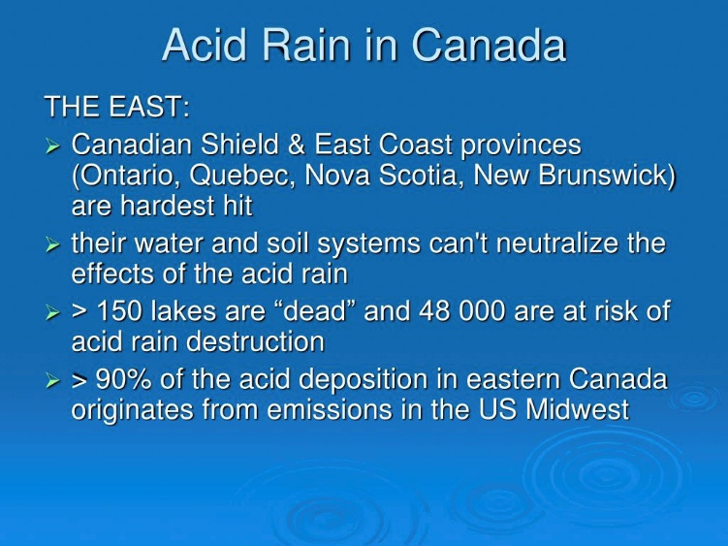
So, if we must pay a tariff for smoke, then it seems to me a reciprocal arrangement whereby Canada receives damages for America’s past negligence that will continue well into the next several decades be considered!
These reparations seem fair to me! What do you think?

