Once we step through the looking glass we can’t go back,
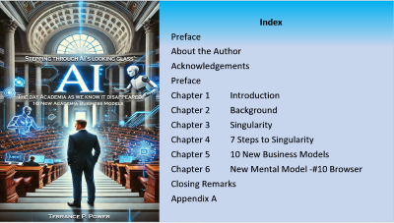

We have just about entered the 4th+ step towards singularity. We’re morphing into that Centaur--- half human and half machine.
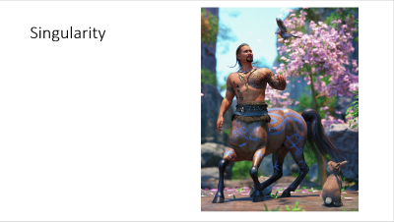
Increasingly a growing concern that humanity might be surrendering control over all we hold dear to AI.
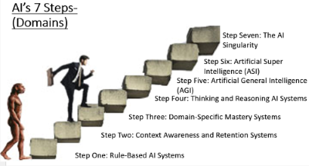
There are two turbulent streams…. Artificial intelligence and robotics.
Artificial intelligence is double edged sword. It offers the ability for innovation across the wide spectrum of all activity’s humans undertake. Not exponential growth but rather ‘a hockey stick’ growth.
But the challenge like nuclear power is … Where are the guardrails to contain it.
Reports daily of indications firms such as Nvidia, Microsoft, Alphabet, Meta, Tesla, OpenAI, and Anthropic’s directing minds are expressing Increasing discomfort as their innovations seize the initiative and growing unprogrammed competencies.
With a common front they advocate for universal AI governance.
For example: Read … “The real AI challenge for CEOs: staying in control of their destiny”--- see Why AI's real challenge for CEOs is staying in control | World Economic Forum
But might I suggest a second level catalyst.
The Oligarch liability if their forecast is correct and something untoward emerges will now be shifted to the federal government.
If government implements AI governance (rules and regulations), then these AI firms having complied have a strong defense. The damages then become government’s problem. Smooth!
The mental model adopted by President Trump announced AI is ‘a hoax’. No need for government’s intervention.
We should understand that AI is not like an automobile manufacturing plant. I am of the opinion the better is to view is see AI as a living, growing innovation.
An entity that will soon be capable of sending out ‘shoots’ in directions not foreseen by ‘their gardeners’.
This impact will affect everyone, especially 18- to 35-year-olds tethered to screens of all sizes. As Faith Popcorn described in The Popcorn Report, they are increasingly cocooned.
Their withdrawal from interaction and “human “relationships will result among many outcomes a rise in mental issues—and stress.
The second stream “robotics” will result massive unemployment.
I can only think of one or two very narrow employment positions the robotics currently cannot replace. Those that require empathy and for the time being movable thumbs. I believe these will be the last of these positions.
As we speak there are dark factories in China producing are electric cars. Seven days a week, 24 hours a day and no unions. Once the capital costs have been made the ongoing maintenance costs are miniscule compared to the legacy costs and operating cost faced by the big three USA automobile companies.
As we speak offloading in Vancouver are 80,000 Chinese EV cars. Costing one third less and better quality than the competition.
Indeed, in China the EV market currently represents almost 40% of all sales. This shift from the gasoline engine to Electric has resulted in 8.9% drop in oil imports. Timely, given the price of a barrel of oil at $104 a barrel: and mitigates growing environmental concerns.
The Chinese military is exploring how humanoid robots could be deployed in future wars and on the battlefield.
Autonomous transportation vehicles of all kinds to Include farm equipment Are rolling out in ever greater numbers
The list goes on.
The question becomes .. How to sustain the masses?
The Roman’s simple answer was with circuses in bread. Today the conversation shifts to the universal guaranteed annual income. But will that be enough? Do humans need more than Maslow’s food , shelter and clothing?
I’m of the opinion the answer is yes—if not, societal turbulence. Think Arab spring!
Income. The trajectory between ‘the have and the have nots’ grows daily. The middle class is disappearing. Wealth is migrating to the hands a small oligarch of billionaires.
I contend they might be described as ‘the puppet masters’ --- the directing minds behind our governments. Look behind the curtain and note donations.
Grounded in the political ideology of Aristotle—the individual over the state-- it grieves me to suggest redistribution of wealth from these folks to support sustainability of the bread and circuses.
No easy answers—but discussions are taking place as to what AI limitations-- regulations ---governance should be put in place.
But the challenge is not easy.
Whoever controls AI in my opinion can control the world.
And the fear of course that countries that do not sign on will push ahead and win the race.
Currently I believe China is behind USA; but if America applies “the brakes” it will not be long before China takes the pole position.
So, can we afford to put on the brakes?
Will we continue in steps through the Looking Glass and hope for the best? As the ‘voice’ in the Haunted Mansion in Disneyland says.. “look around there are no windows and no doors in this room”. Once the door closes—the ride begins!
What do you think?

